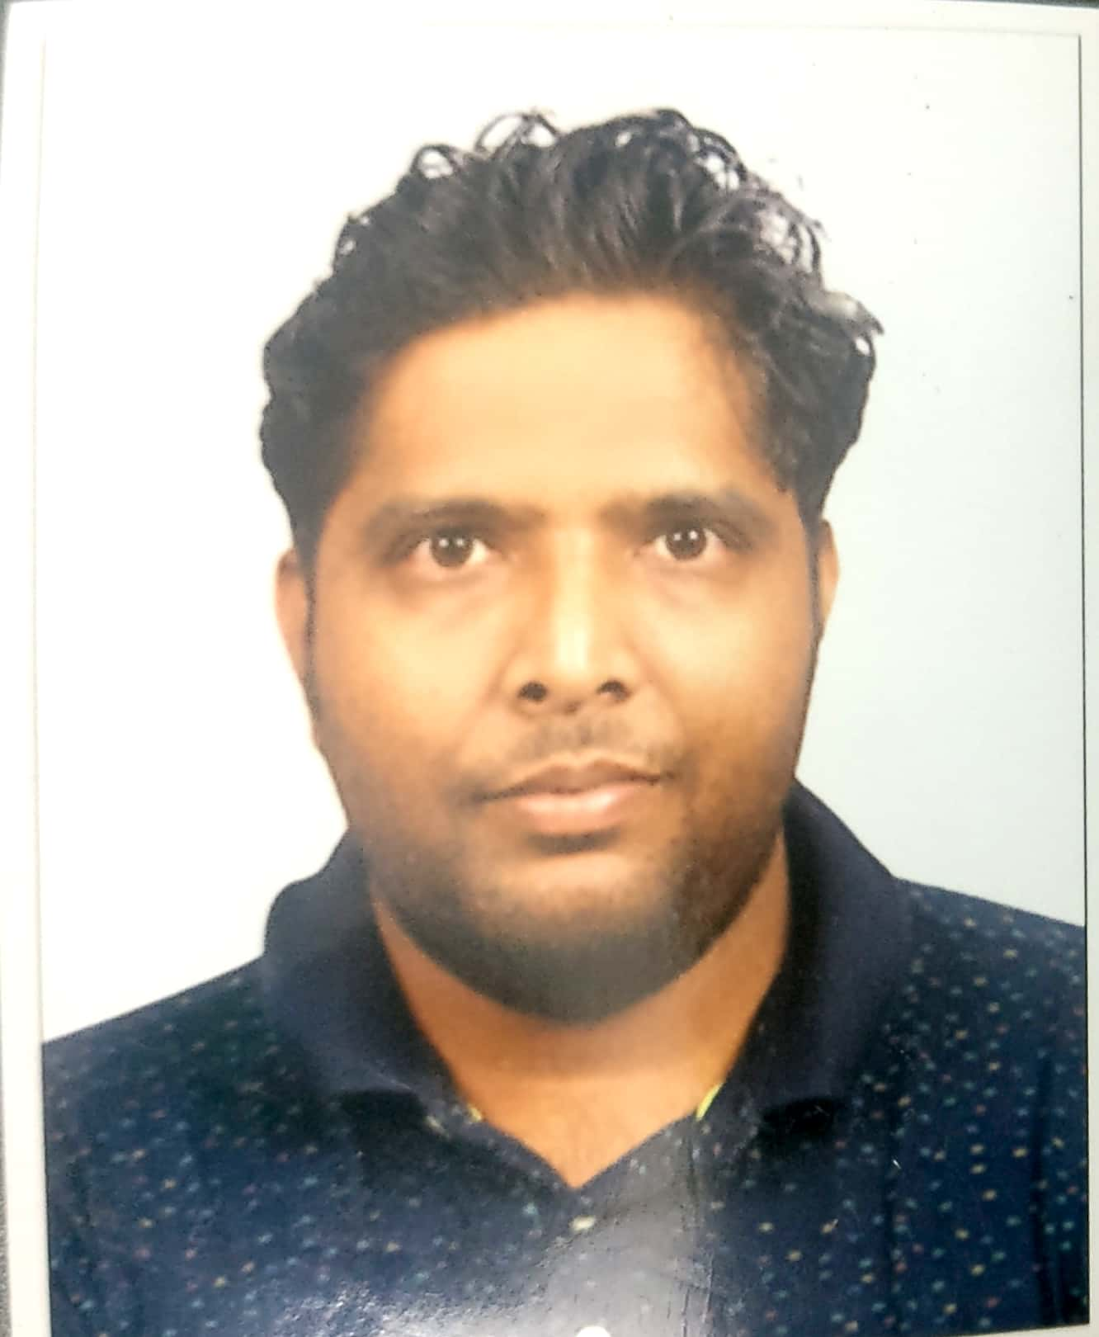
B. VEMA REDDY

Photograph
Contact: +91 9751807770 ~ E-Mail: vema.bapathi@gmail.com

IT EXPERIECNED PROFESSIONAL
Targeting Assignments in:
Software Developer (Embedded C)

PROFILE SUMMARY

Offering over 5+ years of rich experience in:

Embedded Software Development Project Execution Technical Support
Debugging/Designing Research & Development Service Delivery
Client Relationship Management Knowledge Sharing Training

- Expertise in executing Embedded Software Development projects and ensuring delivery of projects within the time & cost parameters
- Knowledge about real-time embedded system; capability to read and understand datasheets as well as developing code
- Recognized proficiency in end-to-end development of embedded software products from requirement analysis to system study, designing, coding, testing, debugging, documentation and implementation
- Excellent analytical, organisational, planning skills with proven capabilities in training & mentoring teams towards achieving organisational goals

WORK EXPERIENCE
Jul 2021 – Oct 2022 : L&T Technology Services as Senior Engineer

Sep’2020 – Jul’2021: Alten, Chennai as Engineer

Feb’2019 – March’2020: Automotive Robotics India Pvt Ltd, Chennai as Embedded Software Developer

Dec’2017 – May’2018: Utthunga Technologies, Bengaluru as Embedded Engineer

Jul’2013-Dec’2013: Kone Elevators, Chennai as Embedded Engineer

Nov’2010-Mar’2012: Signals and Systems, Chennai as Project & Development Engineer

Role:
- Lead complete software life cycles of embedded software development; executed the structural designing & coding of solution for developing the new applications
- Performed coding, module designing, requirement gathering and helped in reviewing test plans for embedded software development
- Defined system software architecture & breaking it down to small manageable modules (middleware and application)
Highlights:
- Steered continuous efforts towards achieving an improved Service Quality, System Stability, Team Productivity, Customer Satisfaction & Project Profitability by taking measures like proper testing comparing the actual result and the expected result, responding to the bugs occurred at site on immediate basis at Kone Elevator organisation.
- Exhibited skills in maintaining a positive work environment by organising events like picnics, team outings and Sport Events which helped in motivating resources to deliver high productivity benchmarks at Utthunga Technologies organisation
- Undertook User friendly User Interface to enhance client satisfaction level at Kone Elevator organisation
- Conducted Hand on Training sessions for the new joiners on Embedded C and C using LPC2129 controller.
- Provided seminars at different engineering colleges on Embedded systems, hired students and trained them post on boarding.

MAJOR PROJECTS

At Automotive Robotics India
Project: Tespa HMI
Environment: C,Embedded C,Python, RasPi-3,GUI,Linux(Ubuntu)
Highlights:
- Developed software to communicate between python and C language using python C extensions technique.
- Developed application software for various features in the project.
Description:
Tespa HMI is a project to read the sensor values from the LVDT sensor and update it on HMI in micron values. And there are many features implemented in order to operate on the sensor values that are obtained from the LVDT sensor, such as Increment, Decrement, Zeroing and many others. There are different screens in order to operate on sensor values.

At Utthunga Technologies:
Project: Energy Meter
Environment: Embedded C, I2C
Micro Controller: STM32F407
Highlights:
- Developed new application software to implement the various kinds of tampering in energy meter
- Prepared Test plan implementation and fixed the issues.
Description:
The Energy Meter designed is used for Tamper Detection like Magnetic tampering, Tilt tampering, Temperature tampering. The user who involves in tampering gets the maximum amount of bill during tampering as the meter detects the tampering and substitutes the maximum value of current and voltage during that time period. Implemented the communication between sensor (which detects the tampering) and the micro controller using Inter-Integrated circuit (I2C).

At Kone Elevators
Project: Green Galaxy
Environment: Embedded C, RTOS,UART
Processor: ARM9
Highlights:
- Developed software for Voice Announcement System in the elevator.
- Developed Fireman’s application in order to evacuate people from the elevator and allow fireman to take actions.
- Developed Attendant Service Application for the elevator such that the Attendant has some privileged actions that can be taken by him to operate the elevator.

Description: A completely renewed flexible elevator solution for residential and commercial buildings with a broad range of safety options, ride comfort and A-class eco efficiency mainly made possible through Embedded Software. Segment: Machine-room-less with a speed of 1.75 m/s and a load capacity of 1150 kg. The completely renewed eco-disc hoisting machines, breaks, hoisting system and elevator car structure, now providing even better ride comfort and even lower energy consumption. The industry’s wide selection of material and over 100 electronic features. A broad set of standard features ensuring elevator safety, accessibility, eco-efficiency and performance, plus additional features to add further value and enhance people flow.

At Fiat Chrysler Automotive
Project: FCA-Thunder
Environment: Python,C++,PREEVISION
Highlights:
- Involved in development of adaptive platform modules such as Machine State management, Power State Listener, and able to test communication using DLT viewer.
- Involved in creation of SWC and interface in PREEvision able to take export and verify it in davinci.

Description:
HPAD system with two performance processors- Denvertons,EYEQ image processor,Aurix Safety chip collects information from perception and chassis dynamics sensors performs sensor fusion along with data from image processor to control vehicle functionality.

At L&T Technology Services(LTTS)
Project: TAAS
Environment: Python, Linux, PyTest FrameWork
Highlights:
Developed automation testcases for Test as a Service using Pytest framework.

Description:
To enable developers to develop against devices located remotely. This framework grants developers with ability to automate the unit test and write the same as a part of the development process. This is common in any open source package development, where the maintainer also does his own unit testing for ever feature written.

TECHNICAL SKILLS

Controllers & Processors: ARM9 (AT91SAM9260), ARM CORTEX (LPC812), STM32F407
Tools and Compilers (IDE): CCS, Code Wright, IAR Embedded WorkBench ,Tkinter
Protocols: UART, I2C, CAN
Software Languages: C, Embedded C, RTOS ,Python
Operating Systems: Linux

EDUCATION

- B.E. in Electronics and Communication Engineering (ECE) from Sri Venkateshwara College Of Engineering, Anna University, Chennai with First Class (64%) in 2009
- HSC from St.Joseph’s Residential School, Sriperumbudur, Chennai in 2005
- SSLC from St.Joseph’s Residential School, Sriperumbudur, Chennai in 2003

PERSONAL DETAILS

Date of Birth: 12th October, 1987
Permanent Address: 50, Nagalapuram Road, Uthukottai, Thiruvallur District 602026
Languages Known: Hindi, Telugu, Tamil and English

